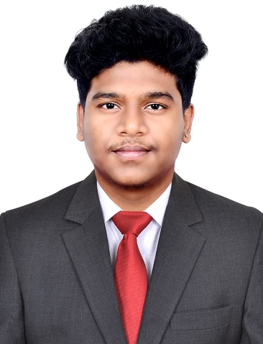

**SHARVESH S**

**Design Engineer | CAD Specialist | Mechanical Engineering Graduate**

**Address** **-** No: 8, Kothaval Chavadi Street Extension, West Saidapet, Chennai-600015.

**Mail ID** **-** [siddhusharvesh@gmail.com](mailto:siddhusharvesh@gmail.com) | **Contact** - (+91) 90254 47076

**LinkedIn** **-** <https://www.linkedin.com/in/sharvesh-s-b33203214>?

**Portfolio -**

**PROFESSIONAL PROFILE**

Highly motivated and skilled Design Engineer with hands-on experience in Creo Parametric, AutoCAD, SolidWorks, SAP and Windchill, currently working with global client Vestas through L&T. Seeking an opportunity to contribute innovative mechanical design solutions in an international engineering environment while expanding my technical and collaborative skills on a global platform.

**EDUCATIONAL QUALIFICATION**

|  |  |  |  |
| --- | --- | --- | --- |
| **Course** | **University / Board** | **Year of passing** | **Percentage/ CGPA** |
| B.E Mechanical Engineering | SRM Easwari Engineering College | 2024 | 8.82(CGPA) |
| HSC | Sri Sitaram Vidyalaya Matriculation Higher Secondary School | 2020 | 66.5 |
| SSLC | Sri Sitaram Vidyalaya Matriculation Higher Secondary School | 2018 | 76.6 |

**INTERNSHIP**

* **EMPEE ENGINEERS** - Learned about Production Lathe Machine, CNC Machine, Mechanical Measuring Instruments. *(Jul 2022 to Aug 2022)*
* **MICRO LAB (P) Ltd, Chennai** - Learned about material testing machines such as Charpy, Izod, Tensile and Universal Testing Machines (UTM). *(Dec 2022 to Jan 2023)*

-Hands on experience on Rockwell hardness tester and Brinell hardness tester.

* **TVS Training and Services** - Gained exposure to automotive service practices and workshop tools, GD&T, industrial safety, quality control, and lean manufacturing principles. *(Feb 2023 to Mar 2023)*

**CERTIFICATIONS & WORKSHOP**

* Introduction to Industry 4.0 and Industrial Internet of Things (NPTEL online certification).
* Rapid Manufacturing (NPTEL online certification).
* Course on AutoCAD Essential.
* Drone workshop in technical event organised by CIT.
* 5th International Conference on Computational Intelligence and Industry 5.0 at VIT.

**PROJECTS**

**Academic Project**

Title: Study on Friction and Wear Behaviour of VC/Ni-P Electroless Composite Coating on Mild Steel

Role: Team Leader.

Led a team project on analysing the friction and wear behaviour of VC/Ni-P electroless composite coatings on mild steel. Conducted tribological tests and surface analysis. Achieved enhanced wear resistance. Successfully showcased the project at the 5th International Conference on Computational Intelligence and Industry 5.0 at Velammal Institute of Technology.

**PROFESSIONAL EXPERIENCE**

**Associate Design Engineer**

L&T Technology Services (Client: Vestas) - Chennai, India | JUN 2024 - Present - Working on the Blade Rack System project used in wind turbine logistics - Designed and modelled mechanical parts using Creo Parametric, managed data in Windchill - Applied material specifications and GD&T for design accuracy - Collaborated with global teams for quality and compliance.

**TECHNICAL & PROFESSIONAL SKILLS**

* **CAD Tools:** Creo Parametric, SolidWorks
* **PLM Systems:** Windchill
* **Engineering Tools:** GD&T, FMEA, BOM Management, Tolerance Stack-up
* **Design Knowledge:** Material Specifications, Sheet Metal Design, Weldments
* **Large Assembly Management:** Hands-on experience handling and modifying complex,

large-scale assemblies

* **Software Proficiency:** MS Office (Excel, Word, PowerPoint), PDF Annotator
* **Documentation:** Engineering Drawings, Change Management, Revision Control.

**FURTHER DETAILS**

**Languages:**

* Tamil
* English
* Hindi (Basic)
* Telugu (Basic)

**Others:**

* Reading Books
* Group Discussion
* Cooking
* Sketching

**DECLARATION**

**“I hereby declare that all the above stated details are true to the best of my knowledge and belief. If you give me an opportunity, I promise you that I will satisfy all your expectations”.**

* **SHARVESH S**